
The SNC heavy duty submersible sewage product has been designed to give you what you want, a durable submersible sewage pump, various impeller designs and high end motor features, all designed to give you long life. The pump features various impeller geometries designed to handle sewage and wastewater applications. The motor features an epoxy resin sealed cable base, an overload “Auto-Cut” motor protector and oil lubricated double mechanical seals.
PRODUCT BULLETIN
MODEL SNC SUBMERSIBLE SEWAGE
Bulletin 330SNC
Edition 2a

Material Specifications
PART | CAST IRON FITTED
Casing | Cast Iron
Impeller | Cast Iron
Shaft | Stainless Steel
Motor Housing | Cast Iron
Mechanical Seal | Carbon/Ceramic  Carbon/Si-Carbide
MODEL SNC SPECIFICATIONS

Casing: The casing is constructed of high tensile cast iron. It is of the volute type, carefully and accurately proportioned to permit smooth flow and to convert high velocity energy of the fluid as it leaves the impeller into pressure. Suction and discharge nozzles are cast integral with the volute. The casing has a vertical centerline discharge. Larger models feature a replaceable case wear ring providing additional protection to the casing. Necessary vent and drain openings are provided.

Impeller: The impeller is of the single vane cutter, vortex or enclosed end suction type, casted in one piece of cast iron material. Single vane cutter style impellers feature a Tungsten-Carbide leading edge designed to cut through stringy solids in the pump fluid. Vortex style impellers create a vortex within the casing minimizing wear on the impeller which leads to increased life. Enclosed impellers feature large solids passing design and high efficiency. All impellers are hydraulically and dynamically balanced prior to assembly and most impellers have pump out vanes standard on the back side of the imepller to reduce material from building up near the stuffing box.

Case Wear Ring: Standard enclosed impellers are designed with integral case wear rings accurately turned to provide close running fits in casing. The diameters of these rings are such as to reduce end thrust to a minimum.

Shaft: The shaft is of high strength 420 stainless steel, ground to accurate dimensions and polished to a smooth surface. It is designed for extra stiffness to avoid all critical speeds in operation.

Rear Cover: The rear cover is constructed of cast iron or other specified material. The rear cover houses the double mechanical seal which has a Carbon/Cermanic motor side and Carbon/Silicon-Carbide pump side face arrangement. Both mechanical seals are of the oil lubricated type to provide excellent lubricating fluid for the seal faces. All seal hardware is located in the oil lubricated seal housing, eliminating potential issues with foreign matter clogging the mechanical seal springs. An oil seal is located just outside of the seal chamber housing, adding a third seal to the pump assembly, which eliminates large solid matter from contacting the outside seal face assembly.

Motor: The motor housing frame is constructed of high tensile cast iron and provides support for the windings, shaft and bearing housing. All American-Marsh submersible motors are air filled for ease in servicing, lower running temperatures and feature Class F insulation. Air filled motors have the advantage of being easier to service due to the fact that the large volume of oil required for operation is not present. Larger motor horsepowers feature a cooling jacket on the motor housing, which lowers operating temperatures and extends motor life. These motors feature a motor overload design that protects the motor from high amperage draw, locked impeller and high temperature issues within the pumping assembly. The cable base of the motor has a compression fitting, an epoxy sealed housing, stripped back motor leads (to prevent wicking of moisture) and o-ring construction to prohibit mousture from entering the motor housing. On larger horsepower frame sizes, a moisture leakage detector is included standard for ultimate protection.
PRODUCT BULLETINMUNICIPALCOMMERCIALINDUSTRIAL
MODEL SNC SUBMERSIBLE Submersible Sewage, Heavy SolidsBuilding Waste,Residential,Process Solids, Industrial
SEWAGEStorm WaterWaste

Easy Lift GRS (Guide Rail System): American-Marsh’s Easy Lift GRS (Guide Rail System) allows the user to easily and efficiently remove and re-install a SBF Submersible Sewage Pump. The Easy Lift GRS consists of a discharge elbow, pump discharge coupling, two rails (not supplied) and a stainless steel lifting chain. The Easy Lift GRS is a must for quickly servicing the pump and motor assembly.

Bulletin 330SNC
Edition 2a

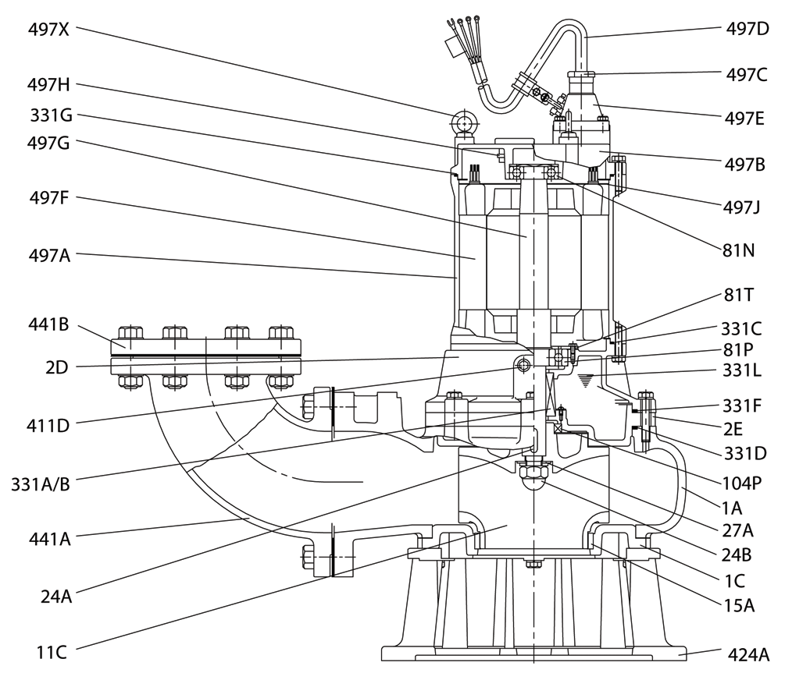
SNC Sectional Drawing

Item Number | Item Description | Num. Req. |  | Item Number | Item Description | Num. Req.
1A | Casing | 1 |  | 331M | Upper Housing Cover O-Ring | 1
1C | Casing Cover | 1 |  | 331N | Motor Lead Base O-Ring | 1
2D | Bearing Bracket | 1 |  | 331X | Mechanical Seal Moisture Sensor | 1
2E | Mechanical Seal Bracket | 1 |  | 331XC | Mech. Seal Moisture Cable Base | 1
11C | Impeller | 1 |  | 331XD | Mech. Seal Moisture Sensor Cable | 1
15A | Casing Wear Ring | 1 |  | 331X | Mechanical Seal Moisture Sensor | 1
24A | Impeller Key | 1 |  | 411D | Oil Plug | 2
24B | Impeller Locknut | 1 |  | 424A | Casing Foot/Strainer | 1
27A | Impeller Lockwasher | 1 |  | 441A | Discharge Elbow | 1
81N | Outboard Bearing | 1 |  | 441B | Companion Flange | 1
81P | Inboard Bearing | 1 |  | 497A | Motor Housing | 1
81T | Inboard Bearing Thrust Plate | 1 |  | 497B | Upper Housing Cover | 1
104P | Oil Lip Seal | 1 |  | 497C | Motor Lead Base Cover | 1
331A | Mechanical Seal (Motor Side) | 1 |  | 497D | Motor Lead | 1
331B | Mechanical Seal (Pump Side) | 1 |  | 497E | Motor Lead Base | 1
331C | Motor Housing O-Ring | 1 |  | 497F | Stator | 1
331D | Mechanical Seal Bracket O-Ring | 1 |  | 497G | Shaft (with Rotor) | 1
331F | Casing O-Ring | 1 |  | 497H | Motor Overload Protection | 1
331G | Upper Housing Cover O-Ring | 1 |  | 497J | Motor Overload Protection Plate | 1
331L | Mechanical Seal Lubricant | 1 |  | 497X | Stainless Steel Eyehook | 3
Recommended spare parts are in BOLD.

